# How to build the Wi-Fi remote for Bestway Lay-Z-Spa

TOC

How to build the Wi-Fi remote for Bestway Lay-Z-Spa 1

1) Checking compatibility 2

Table of models (not exhaustive) 2

Open the pump to verify number of wires 3

2) Hardware 4

BOM 4

Build 4

3) Software 6

6-wire 6

4-wire 6

4) MQTT 7

5) Connect 8

6) FAQ 8

## Checking compatibility

### Table of models (not exhaustive)

|  |  |  |  |  |
| --- | --- | --- | --- | --- |
| **Alias** | **Model Number** | **Pump specs** | **Wires** | **Supported** |
| Riviera | 12220 | Eggshape |  |  |
| Monaco | 54113 | Eggshape |  |  |
| Vegas | 54122 | Eggshape | *6* |  |
| Miami | 54123 | Eggshape | *4/6* | Maybe |
| Palm Springs | 54129 | Eggshape | *4* |  |
| Hawaii/Hydrojet | 54138 | Square | 4 | Yes |
| Palm Springs/Hydrojet | 54144 | Square |  |  |
| Paris | 54148 | Eggshape |  |  |
| Hawaii | 54154 | Eggshape | *4* |  |
| Siena | 54156 | Eggshape | *4* |  |
| Honolulu | 54174 | Eggshape | *6* |  |
| St. Moritz | 54175 | Eggshape |  |  |
| Bali | 54183 | Eggshape |  |  |
| Milan | 54184 | Eggshape |  |  |
| Tahiti | 54186 | Eggshape |  |  |
| Helsinki | 54189 | Eggshape | 6 | Yes |
| Cancun | 54286 | Eggshape |  |  |
| Ibiza | 54291 | Eggshape |  |  |
| Havana | 54298 | Eggshape |  |  |
| 2021 year models | Miami | Square 2021 | 6 | Yes* |
| Vegas | 54112 | ? | 4 |  |
| Coleman SaluSpa | 13804 | Eggshape | 6 |  |

4-wire models are less documented and probably need more electronics and programming skills.

* Might need 560 Ohms resistors between LLC and display, as reported by cyberfly79

### Open the pump to verify number of wires

Unscrew the 6 screws as the picture shows, and carefully lift the display. It is attached with a cable with a connector on it. Check if there are 6 or 4 wires/pins. Other models can be disassembled in a similar manner. On the Hydrojets you must remove the whole cover, not the display. That pump is heavy and fiddlier to disassemble on your own.

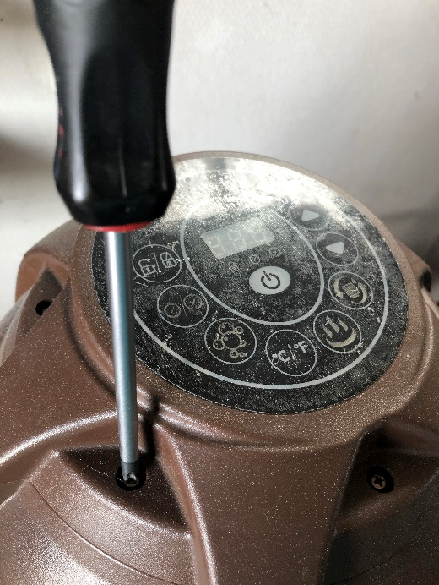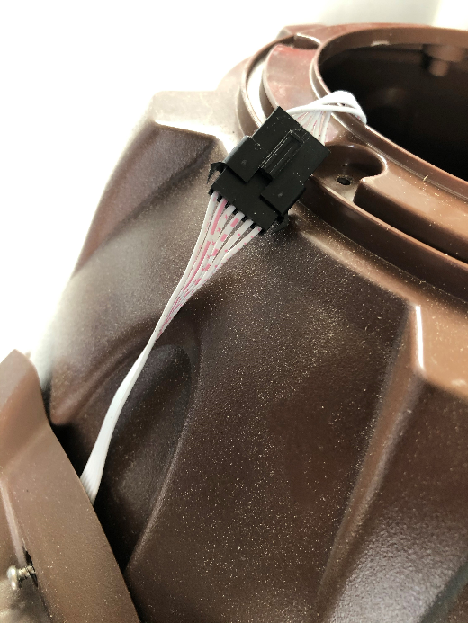

Example – eggshaped 6-wire pump

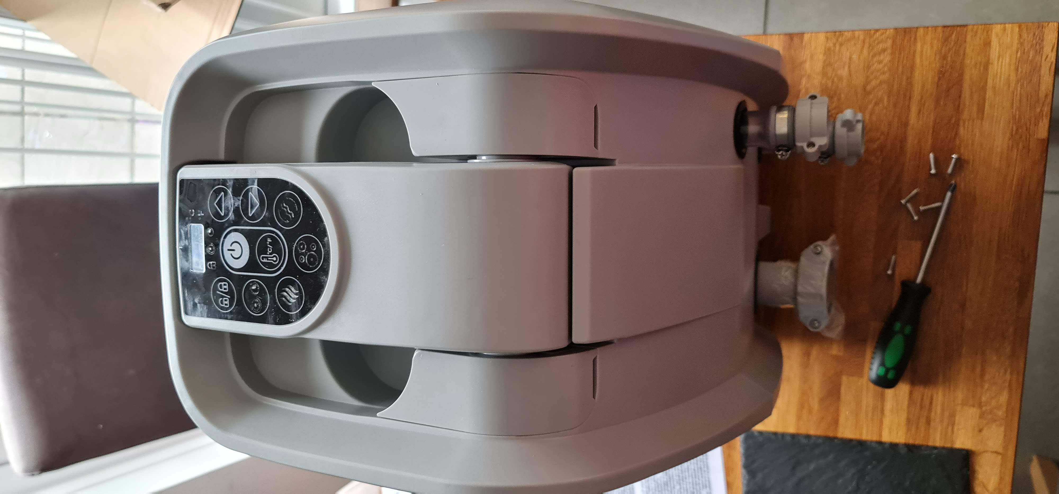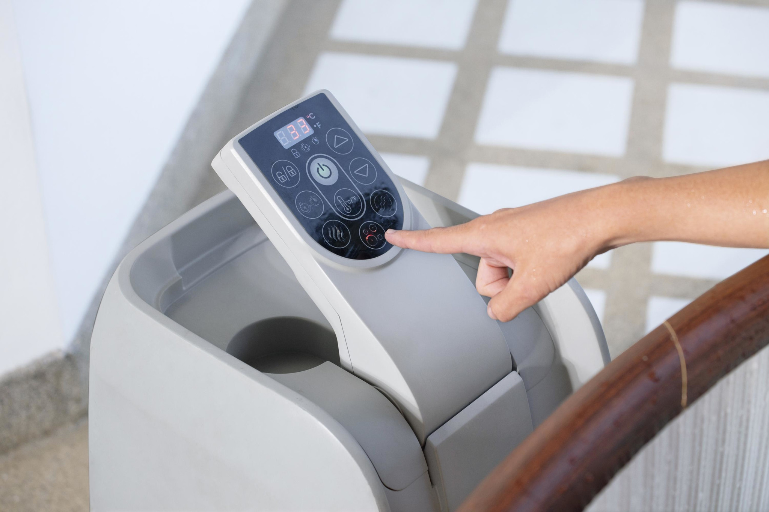

2021 model

## Hardware

### BOM

|  |  |
| --- | --- |
| ESP8266 NodeMCU 1.0 (12E) (NOT ESP32) |  |
| 8 channel bidirectional level converter  TXS0108E |  |
| 6 or 4 pin male/female pair cable 0.1” spacing:  JST SM Housing Connector  [www.wish.com](http://www.wish.com) |  |
| PCB  <https://oshwlab.com/Visualapproach/bestway-wifi-controller> |  |
| Resistor, 10K Ohms, throughhole (Optional for power-on stability. I run without it and it works fine.) | Optional |
| Female header pins (0.1”) to solder to the PCB for the ESP and LLC to be removable. | Optional but highly recommended |

### Build

Solder the 6-wire cables to the PCB (H1, H2):

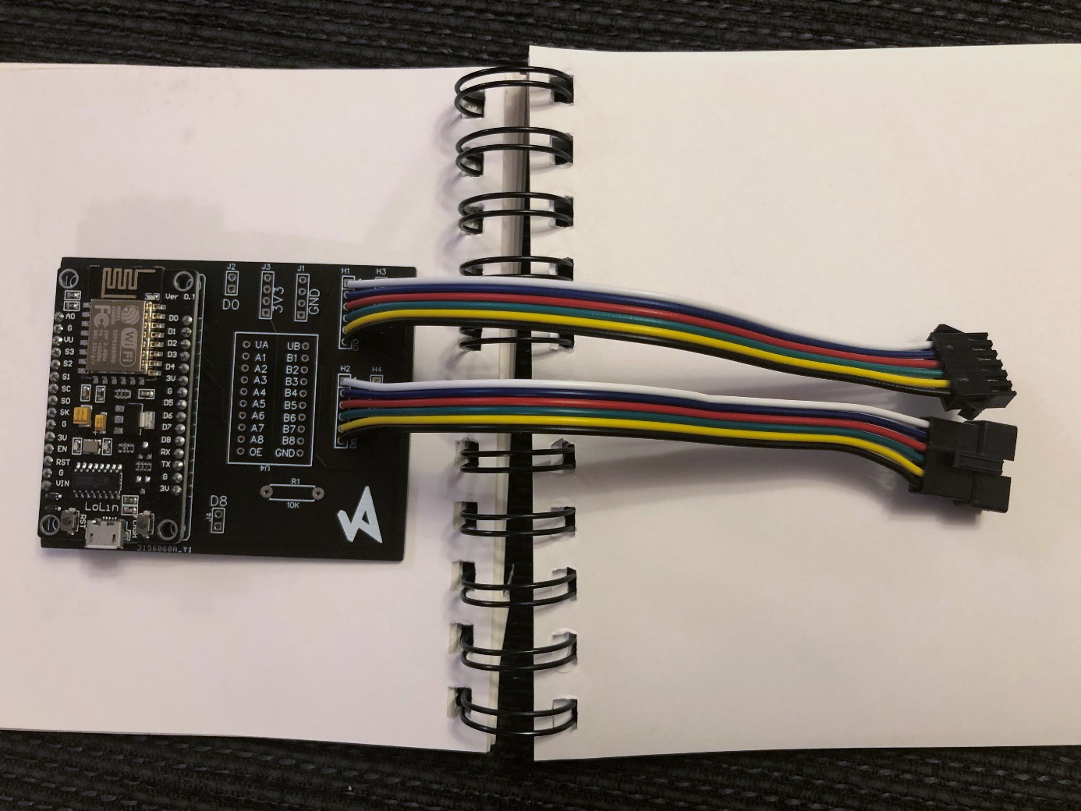

For the 4-wire version, use the 4-hole cables and solder to the two 4-holes section (H3, H4).

Pinout (Colors and pinout on your pump may differ!):

1 (Uppermost. Black on pump) = 5V  
2 (Red on pump) = GND  
3 (Yellow on pump) = DSP TX  
4 (Green on pump) = CIO TX

Solder the 10 K resistor.

You can go on and solder the LLC and ESP8266 directly to the PCB, but I recommend using female headers. In case you want to switch or reuse them.

D0, D8, 3V3 and GND is left empty. They are there for the possibility to connect auxiliary equipment.

Put the PCB in a box, plastic bag or something to protect against water if you want.

Don’t connect the connectors to the pump yet.

## Software

### 6-wire and 4-wire versions

DL and install

~~Arduino IDE~~ [~~https://www.arduino.cc/~~](https://www.arduino.cc/)

[~~BWC_v2.0.0 library~~](https://github.com/visualapproach/WiFi-remote-for-Bestway-Lay-Z-SPA/tree/master/Code)

[~~LittleFS upload tool~~](https://github.com/earlephilhower/arduino-esp8266littlefs-plugin/releases)

~~From Arduino library manager, install~~

~~ArduinoJSON (Benoit Blanchon)~~

~~ESPDateTime~~ [~~https://github.com/mcxiaoke/ESPDateTime~~](https://github.com/mcxiaoke/ESPDateTime)

~~WebSockets~~ [~~https://github.com/Links2004/arduinoWebSockets~~](https://github.com/Links2004/arduinoWebSockets)

~~WiFiManager~~ [~~https://github.com/tzapu/WiFiManager~~](https://github.com/tzapu/WiFiManager)

~~LittleFS~~ [~~https://arduino-esp8266.readthedocs.io/en/latest/filesystem.html#uploading-files-to-file-system~~](https://arduino-esp8266.readthedocs.io/en/latest/filesystem.html#uploading-files-to-file-system)

~~And for MQTT sketch also~~

~~PubSubClient~~ [~~https://github.com/knolleary/pubsubclient~~](https://github.com/knolleary/pubsubclient)

Visual studio code: <https://code.visualstudio.com/download>

From within VSC, click on Extensions icon (ctrl+shift+X). Select PlatformIO IDE and install.

From the new platformio icon, open folder “6-wire-version” or “4-wire-version”.

*If you have a year 2021 model you need to edit the file* ***“BWC_8266_globals.h”*** *like this*

***//if you have a 2021(+) year model, comment the line below***

***#define PRE2021***

*To*

***//if you have a 2021(+) year model, comment the line below***

***//#define PRE2021***

~~Open File/examples/BWC2.0.0/.. from the Arduino IDE.~~

~~Select the right board (NodeMCU12E), and set "FS 2MB/OTA 1MB", speed 80 MHz. select correct COM port.~~

Upload sketch via USB. (Right arrow at bottom of screen) ~~Password “esp8266”~~

Upload LittleFS Data or you will get a 404! Click platformio icon, go to PROJECT TASKS > nodemcuv2 > Platform and build filesystem image, then upload filesystem image.

An Access Point is created called "Auto portal". Log in and enter your wifi credentials. Visit IP/ and click "Go to config page" Enter your settings, click SAVE. The device’s IP is shown in the serial monitor window.

From now on you can update the device over the air (OTA) by ~~selecting the new IP instead of the COM port. You need to restart Arduino IDE for this to show up.~~ Editing platformio.ini file.

## Web interface

Main page (/index.html)

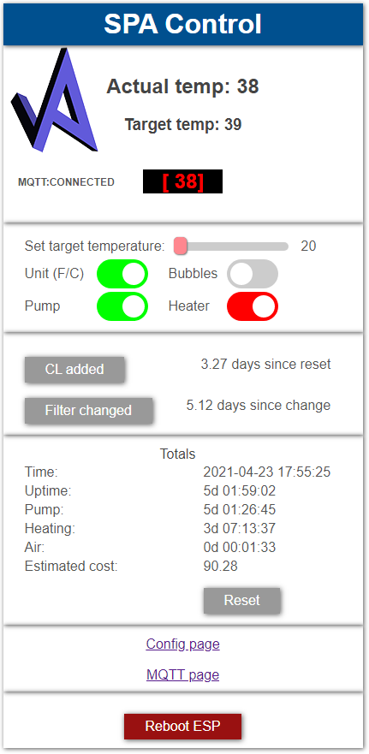Main page shows information about the spa, like temperature, and elapsed time since last filter change, chlorine added and how long the pump has been running etc. Press [CL added] or [Filter changed] to reset the timer. These buttons will turn red when overdue. Pressing the [Reset] button will reset the Totals times.

[Reboot ESP] restarts the ESP 8266. Just in case you want to hear that lovely melody and read the greeting on the display again.

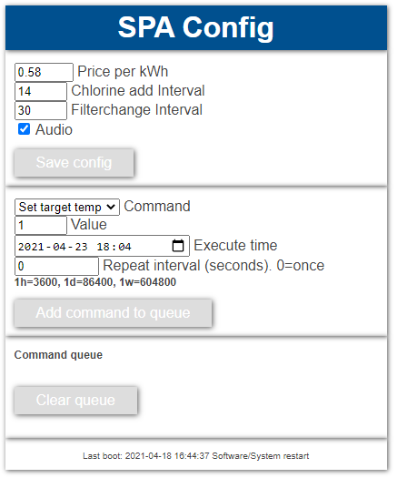On the config page you can set

- your electricity price (so main page can guesstimate your bill)

- how often you want to add chlorine or switch filter.

- if you want the display to be playing tones or be silent (only 6-wire)

In the next section you can add commands to the command queue. For instance you could set target temp to 20 on Sunday evenings, and 40 on Thursday mornings. After a couple of seconds, the added command will show up in the queue. Max queue length is 10.

MQTT page

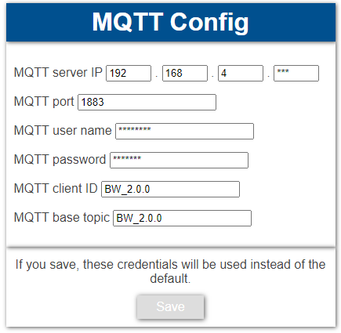

Secret upload page (/upload.html)

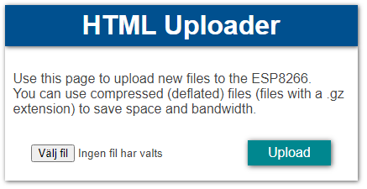Use this to upload updated files like index.html etc

## Connect

Unplug pump from mains! Connect device to pump. Close the display with the screws. Turn on pump and enjoy.

## MQTT

This chapter is for advanced users. If you know what MQTT is, and have an MQTT broker, this is what you need to know:

There is two ways to enter your credentials. You can edit the “globals.h” file before compiling and then you are done with it. Or you can go to the web interface and click on the MQTT link. If you save from the MQTT web page it will override globals.h.

Device is publishing following topics:

**BW_2.0.0/status**

**BW_2.0.0/MAC_Address**

**BW_2.0.0/MQTT_Connect_Count**

**BW_2.0.0/message**

Device is subscribing to topic **BW_2.0.0/command**

Payload in **message** is a JSON string with these key/value pairs:

|  |  |
| --- | --- |
| **KEY** | **VALUE** |
| LCK | LOCKEDSTATE |
| PWR | POWERSTATE |
| UNT | UNITSTATE (0=F, 1=C) |
| AIR | BUBBLESSTATE |
| GRN | HEATGRNSTATE |
| RED | HEATREDSTATE |
| FLT | PUMPSTATE |
| TGT | TARGET TEMP |
| TMP | TEMPERATURE |
| CH1 | CHAR1 DISPLAY’S FIRST CHARACTER |
| CH2 | CHAR2 |
| CH3 | CHAR3 |

Payload in **command** must be a JSON string with these key/value pairs:

|  |  |
| --- | --- |
| **KEY** | **VALUE** |
| CMD | INTEGER, see next table |
| VALUE | MIXED |
| XTIME | Execution time in UNIX TIMESTAMP or 0 for immediate action |
| INTERVAL | Repeat every Nth second INTEGER or 0 for NO REPEAT |

Available commands (CMD) are

|  |  |
| --- | --- |
| 0 | SETTARGET |
| 1 | SETUNIT |
| 2 | SETBUBBLES |
| 3 | SETHEATER |
| 4 | SETPUMP |
| 5 | RESETQ (clear command queue) |
| 6 | REBOOTESP |
| 7 | GETTARGET (internal use) |
| 8 | RESETTIMES |
| 9 | RESETCLTIMER |
| 10 | RESETFTIMER |
| 11 | SETJETS (only some 4-wire models) |
| 12 | TAKECONTROL (only 4-wire) |

## FAQ

<https://github.com/visualapproach/WiFi-remote-for-Bestway-Lay-Z-SPA/discussions>

If you like this project, please consider a donation: [PayPal.me/TLandahl](http://paypal.me/TLandahl)